NST21022 - Practical for Network Switching and Routing
Department of Information and Communication Technology
Faculty of Technology
Lab sheet :17
Reg. Number: SEU/IS/20/ICT/084
Academic Year :2020/2021
Practical No :17

Title: Configure IPv4 and IPv6 Default and Static Routes

Aim:
● Getting familiar with IPv4 and IPv6 Default and Static Routes
Task:
● Configure IPv4 Default Routes
● Configure IPv4 Static Routes
● Configure IPv4 Host Routes
● Configure IPv6 Default Routes
● Configure IPv6 Static Routes
● Configure IPv6 Host Routes

Activities
Use “NST21022 Lab sheet 19.pka” file
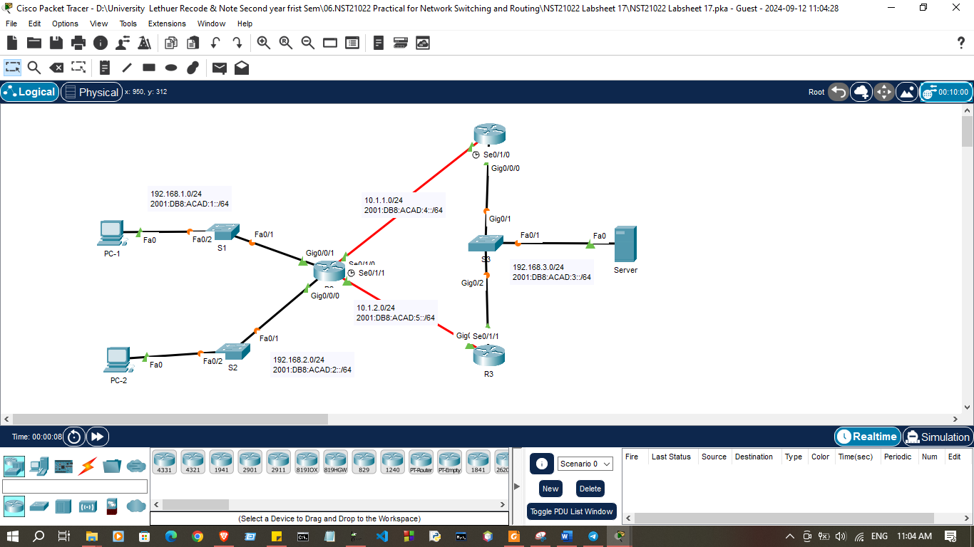
Addressing Table
Device | Interface | IP address / Prefix
R1 | G0/0/0 | 192.168.3.1/24
R1 | G0/0/0 | 2001:DB8:ACAD:3::1/64
R1 | S0/1/0 | 10.1.1.1/24
R1 | S0/1/0 | 2001:DB8:ACAD:4::1/64
R2 | G0/0/0 | 192.168.2.1/24
R2 | G0/0/0 | 2001:DB8:ACAD:2::1/64
R2 | G0/0/1 | 192.168.1.1/24
R2 | G0/0/1 | 2001:DB8:ACAD:1::1/64
R2 | S0/1/0 | 10.1.1.2/24
R2 | S0/1/0 | 2001:DB8:ACAD:4::2/64
R2 | S0/1/1 | 10.1.2.2/24
R2 | S0/1/1 | 2001:DB8:ACAD:5::2/64
R3 | G0/0/0 | 192.168.3.2/24
R3 | G0/0/0 | 2001:DB8:ACAD:3::2/64
R3 | S0/1/1 | 10.1.2.1/24
R3 | S0/1/1 | 2001:DB8:ACAD:5::1/64
PC-1 | NIC | 192.168.1.10/24
PC-1 | NIC | 2001:DB8:ACAD:1::10/64
PC-2 | NIC | 192.168.2.10/24
PC-2 | NIC | 2001:DB8:ACAD:2::10/64
Server | NIC | 192.168.3.10/24
Server | NIC | 2001:DB8:ACAD:3::10/64

Exercise 01: Configure IPv4 Routes
1. Configure IPv4 Default Routes
a. On R1, configure next hop IPv4 default static route. This primary default router should be through router R2.

R1(config)#ip route 0.0.0.0 0.0.0.0 10.1.1.2

R1>enable
R1#configure terminal
Enter configuration commands, one per line. End with CNTL/Z.
R1(config)#
R1(config)#ip route 0.0.0.0 0.0.0.0 10.1.1.2

R1(config)#
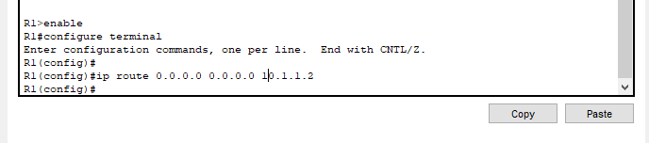

b. On R1, configure directly connected IPv4 floating static default route. This default route should be through router R3. It should have an administrative distance of 5.

R1(config)#ip route 0.0.0.0 0.0.0.0 G0/0/0 5
R1(config)#ip route 0.0.0.0 0.0.0.0 G0/0/0 5
R1(config)#

R1(config)#
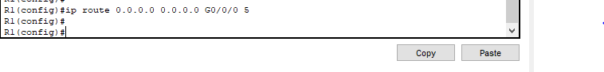

2. Configure IPv4 Static Routes
a. On R1, configure a next hop IPv4 static route to the LAN 1 network through R2.

R1(config)#ip route 192.168.1.0 255.255.255.0 10.1.1.2
R1>enable
R1#configure terminal
Enter configuration commands, one per line. End with CNTL/Z.
R1(config)#ip route 192.168.1.0 255.255.255.0 192.168.2.1 5

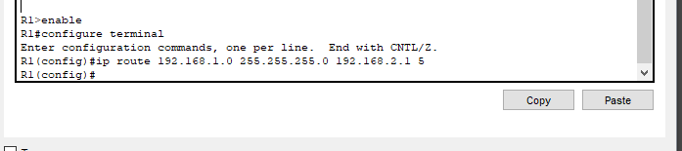
R1(config)#

b. On R1, configure a next hop IPv4 static route to the LAN 2 network through R3

R1(config)#ip route 192.168.2.0 255.255.255.0 10.1.1.2
R1(config)#ip route 192.168.2.0 255.255.255.0 10.1.1.2

R1(config)#
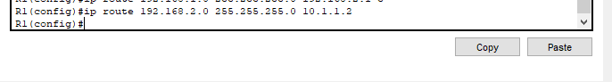

c. On R1, configure a directly connected IPv4 floating static route to the LAN 1 network through R3, use administrative distance 5.

R1(config)#ip route 192.168.1.0 255.255.255.0 G0/0/0 5

R1(config)#ip route 192.168.1.0 255.255.255.0 G0/0/0 5

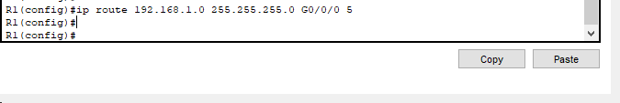
R1(config)#

d. On R1, configure a directly connected IPv4 floating static route to the LAN 2 network through R3, use administrative distance 5.

R1(config)#ip route 192.168.2.0 255.255.255.0 G0/0/0 5
R1(config)#ip route 192.168.2.0 255.255.255.0 G0/0/0 5

R1(config)#

3. Configure IPv4 Host Routes
a. On R2, configure an IPv4 next hop host route to the Server through R1.

R2(config)#ip route 192.168.3.10 255.255.255.255 10.1.1.1
R2>enable
R2#configure terminal
Enter configuration commands, one per line. End with CNTL/Z.
R2(config)#ip route 192.168.3.10 255.255.255.255 10.1.1.1

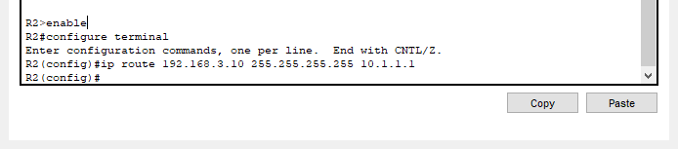
R2(config)#

b. On R2, configure an IPv4 directly connected floating host route to the Server through R3, use administrative distance 5.

R2(config)#ip route 192.168.3.10 255.255.255.255 S0/1/1 5
R2(config)#ip route 192.168.3.10 255.255.255.255 S0/1/1 5

R2(config)#
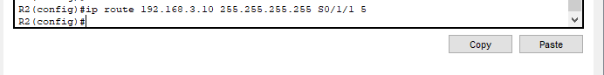

Exercise 02: Configure IPv6 Routes
1. Configure IPv6 Default Routes
a. On R1, configure next hop IPv6 default static route. This primary default router should be through router R2.

R1(config)#ipv6 route ::/0 2001:DB8:ACAD:4::2
R1(config)#ipv6 route ::/0 2001:DB8:ACAD:4::2

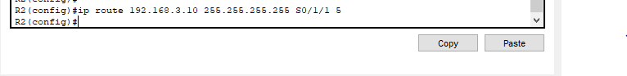
R1(config)#

b. On R1, configure directly connected IPv6 floating static default route. This default route should be through router R3. It should have an administrative distance of 5.

R1(config)#ipv6 route ::/0 G0/0/0 5
R1(config)#ipv6 route ::/0 G0/0/0 5

R1(config)#

2. Configure IPv6 Static Routes
a. On R1, configure a next hop IPv6 static route to the LAN 1 network through R2.

R1(config)#ipv6 route 2001:DB8:ACAD:1::/64 2001:DB8:ACAD:4::2
R1(config)#
R1(config)#ipv6 route 2001:DB8:ACAD:1::/64 2001:DB8:ACAD:4::2

R1(config)#

b. On R1, configure a next hop IPv6 static route to the LAN 2 network through R3

R1(config)#ipv6 route 2001:DB8:ACAD:2::/64 2001:DB8:ACAD:4::2
R1(config)#ipv6 route 2001:DB8:ACAD:2::/64 2001:DB8:ACAD:4::2

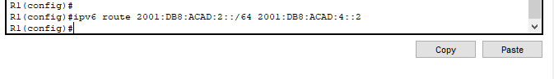
R1(config)#

c. On R1, configure a directly connected IPv6 floating static route to the LAN 1 network through R3, use administrative distance 5.

R1(config)#ipv6 route 2001:DB8:ACAD:1::/64 G0/0/0 5
R1(config)#ipv6 route 2001:DB8:ACAD:1::/64 G0/0/0 5

R1(config)#
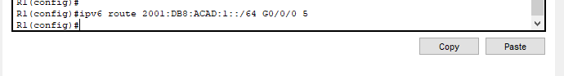

d. On R1, configure a directly connected IPv6 floating static route to the LAN 2 network through R3, use administrative distance 5.

R1(config)#ipv6 route 2001:DB8:ACAD:2::/64 G0/0/0 5
R1(config)#ipv6 route 2001:DB8:ACAD:2::/64 G0/0/0 5

R1(config)#
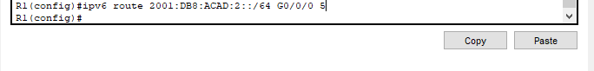

3. Configure IPv6 Host Routes
a. On R2, configure an IPv6 next hop host route to the Server through R1.

R2(config)#ipv6 route 2001:DB8:ACAD:3::10/128 2001:DB8:ACAD:4::1
R2(config)#ipv6 route 2001:DB8:ACAD:3::10/128 2001:DB8:ACAD:4::1

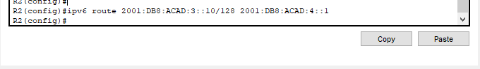
R2(config)#

b. On R2, configure an IPv6 directly connected floating host route to the Server through R3, use administrative distance 5.

R2(config)#ipv6 route 2001:DB8:ACAD:3::10/128 S0/1/1 5
R2(config)#ipv6 route 2001:DB8:ACAD:3::10/128 S0/1/1 5
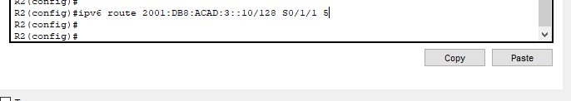
R2(config)#

Discussion
In this lab session, we explored how to configure both IPv4 and IPv6 default and static routes to ensure proper network communication. We began by setting up IPv4 default routes, which direct all traffic with no specific destination toward a default gateway. Next, we configured IPv4 static routes to manually define paths for specific networks, followed by host routes to route traffic to individual IP addresses. Moving to IPv6, we repeated the process by configuring IPv6 default routes to handle traffic not matched by any other routes. We also set up IPv6 static routes for designated networks and IPv6 host routes for individual addresses. These configurations allowed us to manually control the routing paths and ensure efficient traffic flow between networks.

